Qtree Creation/
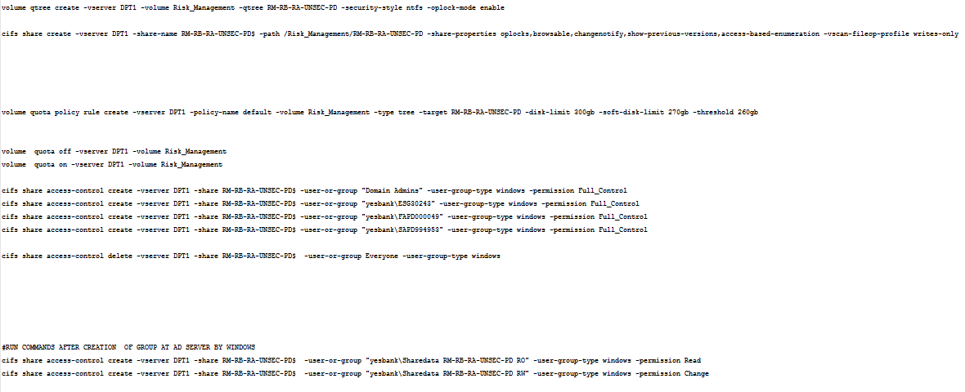
DNS MANAGEMENT:

To check the DNS status of the vserver
vserver services name-service dns check -vserver vs0

Explains about AD and DNS management in SVM
https://docs.aws.amazon.com/fsx/latest/ONTAPGuide/managing-your-existing-svm-to-ad.html

